- A 63.0−g sample of dinitrogen monoxide is confined in a 4.68−L vessel. What is the pressure (in atm) at 111°C?
- In the figure shown, what is the pressure of the gas in the flask (in kPa) if the barometer reads 749.6 mmHg? (Δh = 5.95 cm) 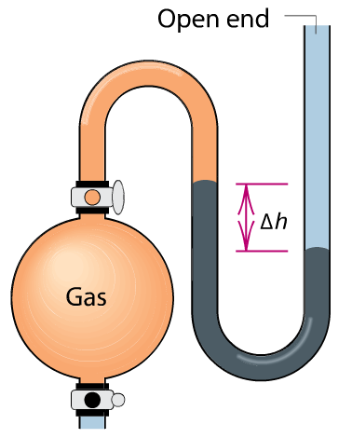
- A sample of an unknown gas effuses in 10.7 min. An equal volume of H₂ in the same apparatus under the same conditions effuses in 2.42 min. What is the molar mass of the unknown gas?
- A sample of Freon−12 (CF₂Cl₂) occupies 10.0 L at 352 K and 124.20 kPa. Find its volume at STP.
- Aluminum reacts with excess hydrochloric acid to form aqueous aluminum chloride and 39.5 mL of hydrogen gas over water at 27°C and 751 mmHg. How many grams of aluminum reacted? The partial pressure of water at 27°C is 26.8 mmHg.
- An environmental chemist sampling industrial exhaust gases from a coal-burning plant collects a CO₂−SO₂−H₂O mixture in a 21.0−L steel tank until the pressure reaches 950.6 torr at 46.0°C.
- How many moles of gas are collected?
- If the SO₂ concentration in the mixture is 2.37 × 10³ parts per million by volume (ppmv), what is its partial pressure?
[Hint: ppmv = (volume of component/volume of mixture) × 10⁶.]
7. Xenon hexafluoride was one of the first noble gas compounds synthesized. The solid reacts rapidly with the silicon dioxide in glass or quartz containers to form liquid XeOF₄ and gaseous silicon tetrafluoride. What is the pressure in a 1.00−L container at 25°C after 7.85 g of xenon hexafluoride reacts? (Assume that silicon tetrafluoride is the only gas present and that it occupies the entire volume.)
8. On a certain winter day in Utah, the average atmospheric pressure is 654 torr. What is the molar density (in mol/L) of the air if the temperature is −18°C?
9. How many moles of gaseous arsine (AsH₃) occupy 0.568 L at STP?
10. What is the density of gaseous arsine?
11. A mixture of CO₂ and Kr weighs 31.0 g and exerts a pressure of 0.667 atm in its container. Since Kr is expensive, you wish to recover it from the mixture. After the CO₂ is completely removed by absorption with NaOH(s), the pressure in the container is 0.289 atm.
- How many grams of CO₂ were originally present?
- How many grams of Kr can you recover?
12. After 0.600 L of Ar at 1.39 atm and 224°C is mixed with 0.200 L of O₂ at 510 torr and 142°C in a 400.−mL flask at 26°C, what is the pressure in the flask?
13. How many grams of phosphine (PH₃) can form when 11.0 g of phosphorus and 76.8 L of hydrogen gas react at STP?

P₄(s) + H₂(g) → PH₃(g) (Unbalanced)

14. A. Convert 1.055 atm to mmHg.
B. Convert 644 torr to bar.
C. Convert 649 kPa to atm.
D. Convert 845 mmHg to kPa.
15. A sample of chlorine gas is confined in a 6.84−L container at 426 torr and 25.0°C.

How many moles of gas are in the sample?

16. A long glass tube, sealed at one end, has an inner diameter of 11.2 mm. The tube is filled with water and inverted into a pail of water. If the atmospheric pressure is 778 mmHg, how high (in mmH₂O) is the column of water in the tube? (d of Hg = 13.5 g/mL; d of H₂O = 1.00 g/mL)
17. On a cool, rainy day, the barometric pressure is 702 mmHg. Calculate the barometric pressure in centimeters of water (cmH₂O) (d of Hg = 13.5 g/mL; d of H₂O = 1.00 g/mL).

